1. **How good is your performance when you train (and/or validate) using all but one teammember's data and test on the remaining teammember's data? Repeat this for each teammember being the test case multiple times (at least 3x each). Back up your response with graphs and/or tables of results.**

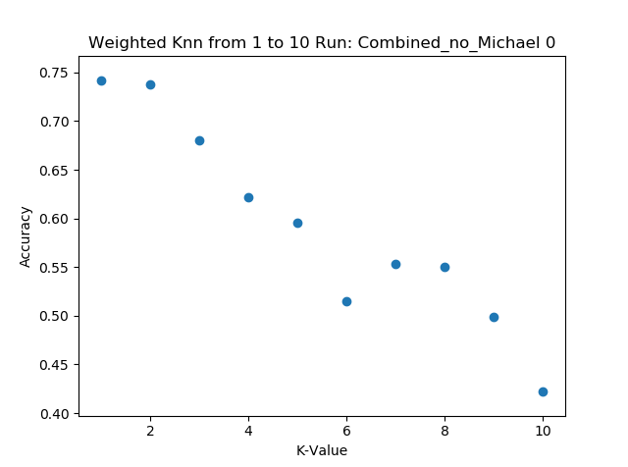 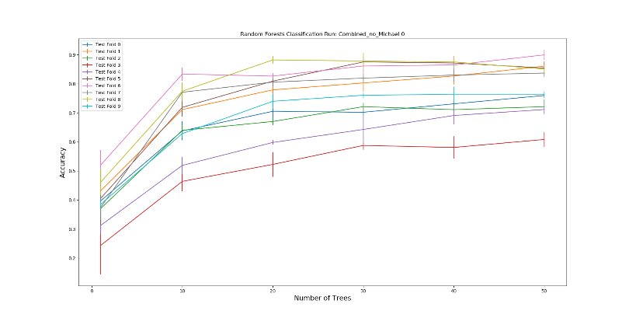

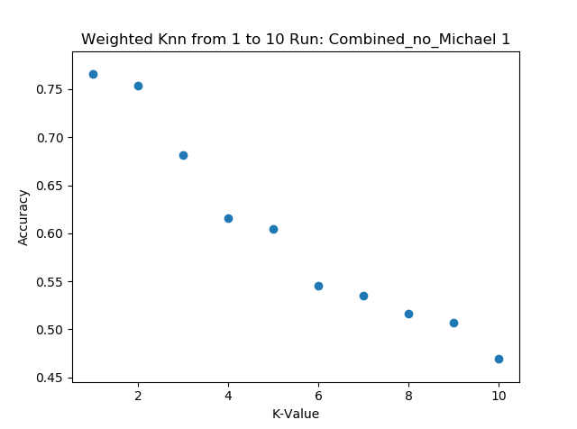 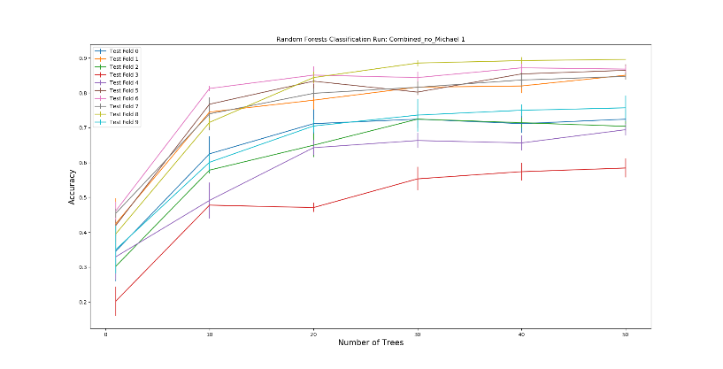

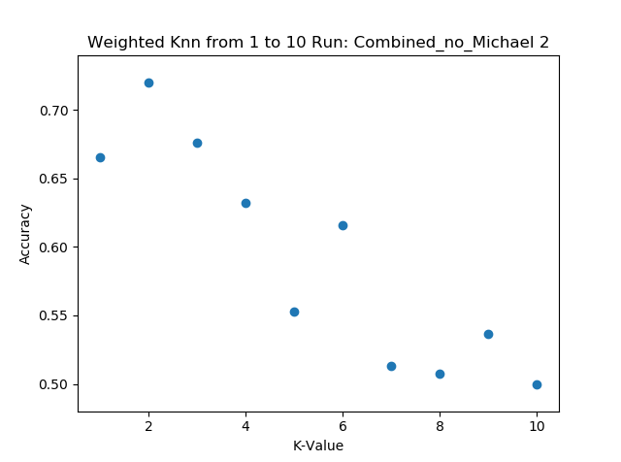 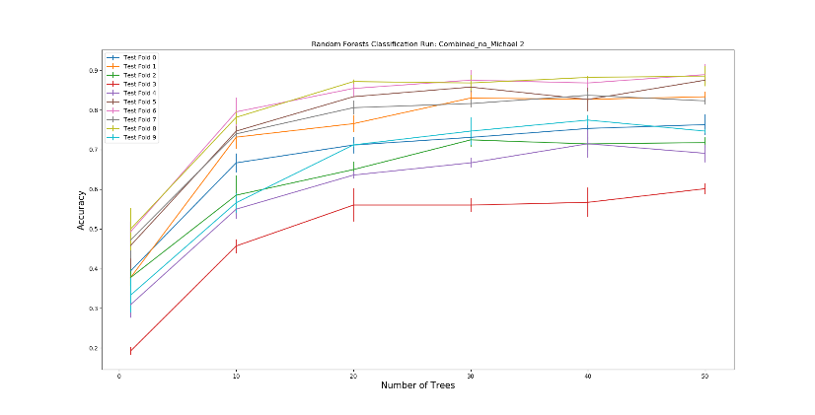

**Figure 1:** The graphs above depict the results when Michael’s data was taken away. Ran 3 times. K-Value: 1 – 10. Number of trees: 0 – 50.

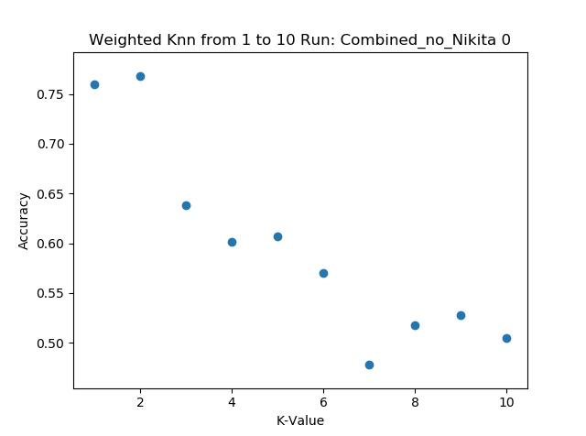 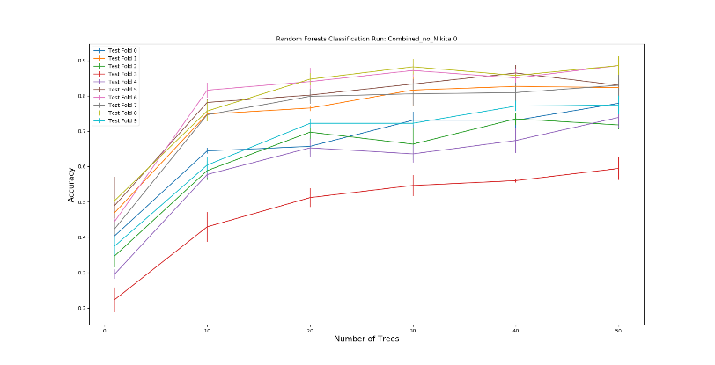

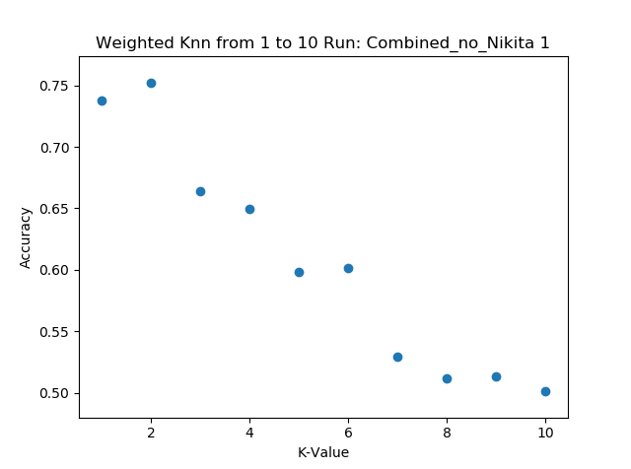 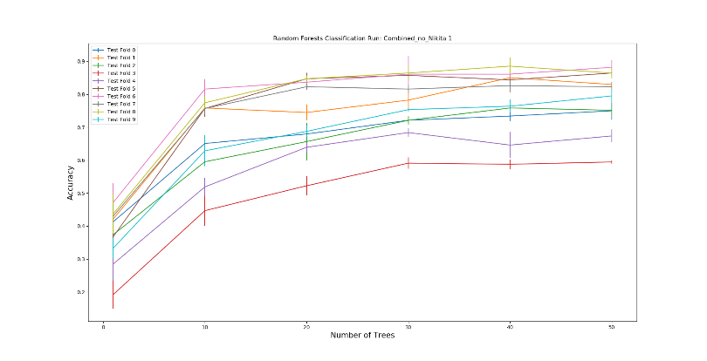

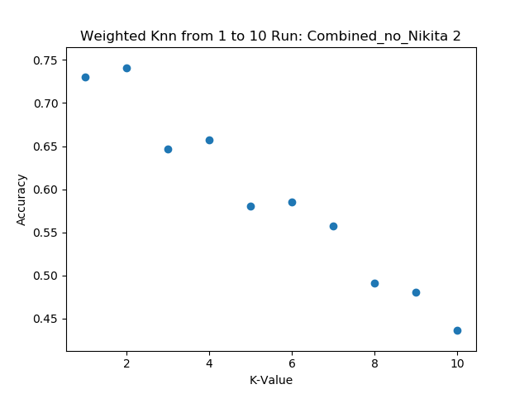 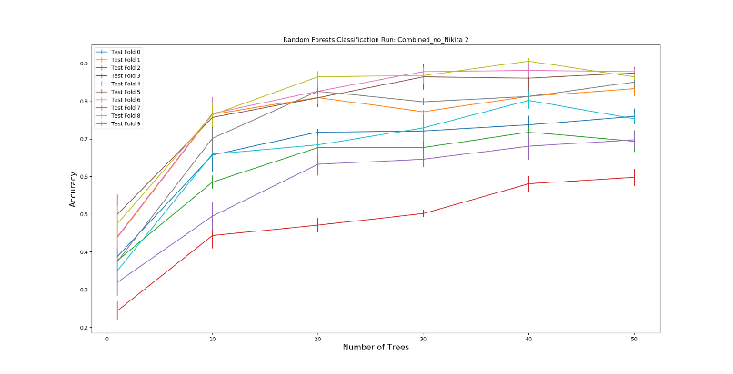

**Figure 2:** The graphs above depict the results when Nikita’s data was taken away. Ran 3 times. K-Value: 1 – 10. Number of trees: 0 – 50.

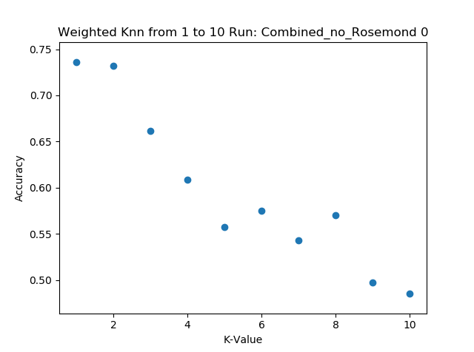 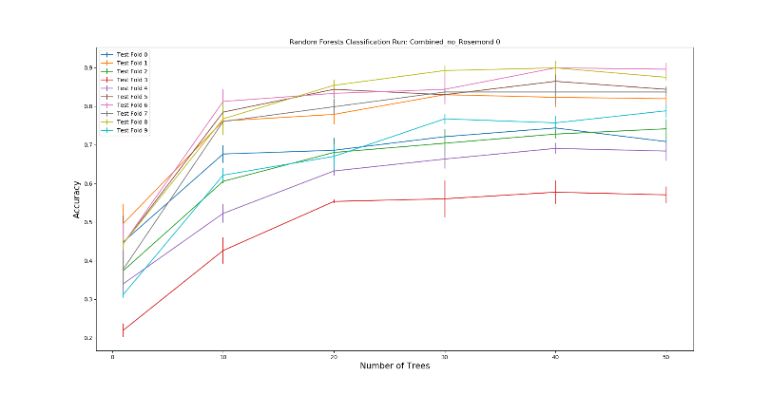

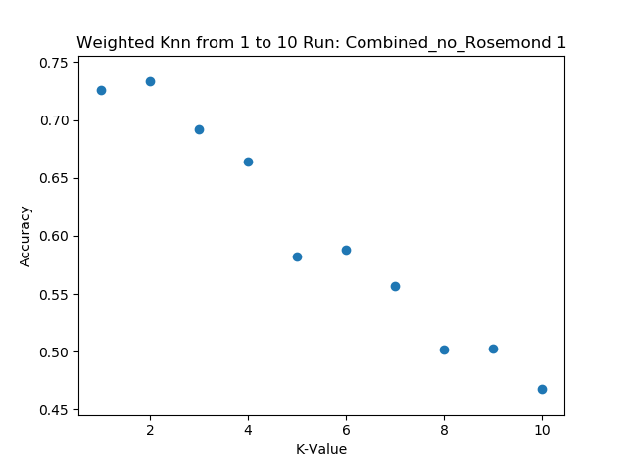 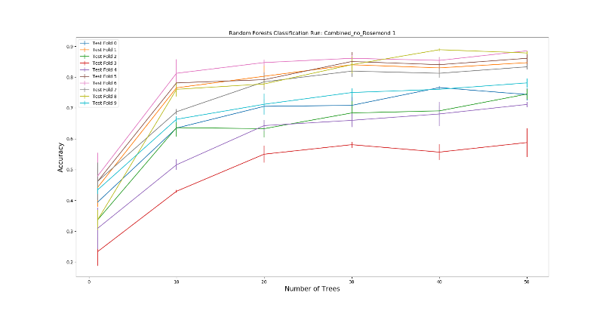

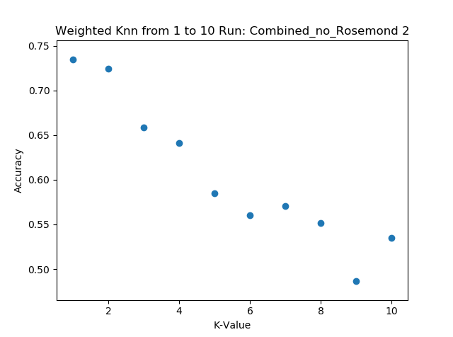 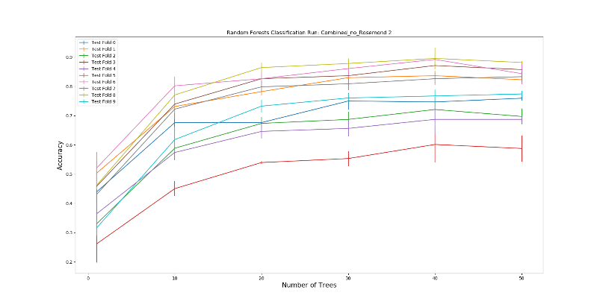

**Figure 3:** The graphs above depict the results when Rosemond’s data was taken away. Ran 3 times. K-Value: 1 – 10. Number of trees: 0 – 50.

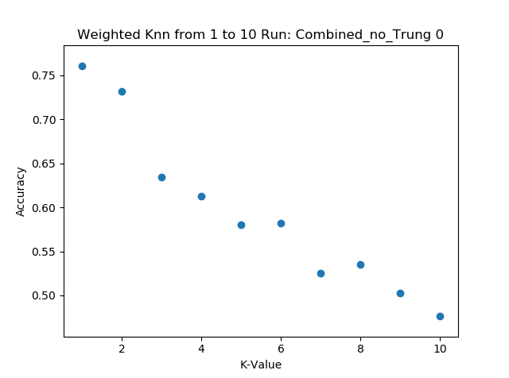 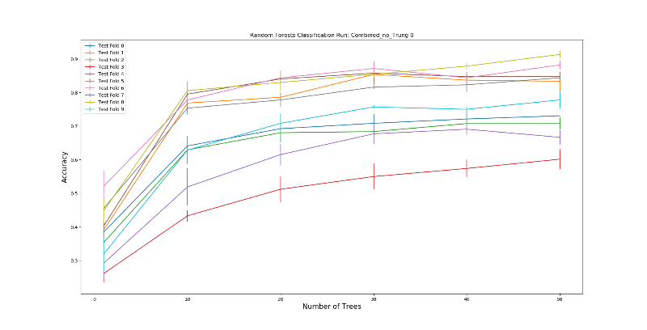

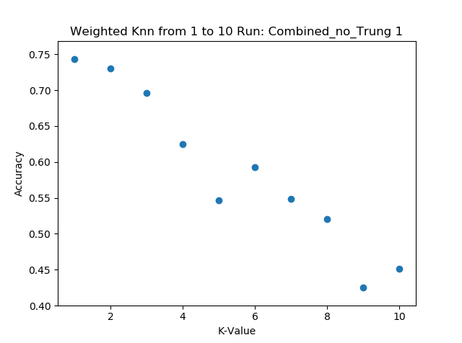 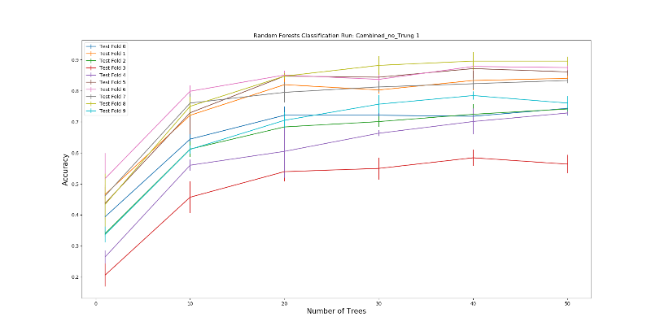

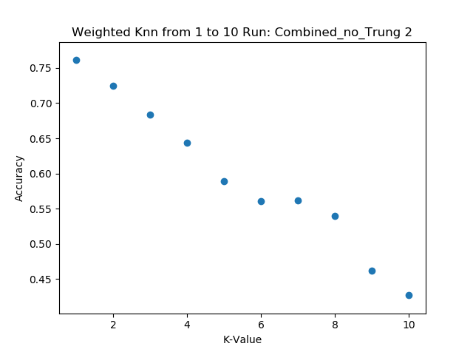 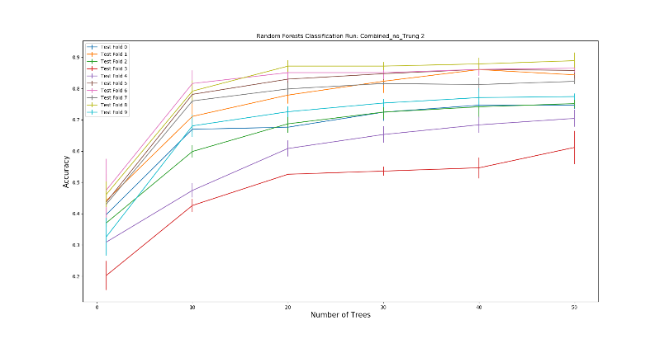

**Figure 4:** The graphs above depict the results when Trung’s data was taken away. Ran 3 times. K-Value: 1 – 10. Number of trees: 0 – 50.

All our pictures were about the same, and we didn’t have much noise in our backgrounds like other image datasets. As a result of this, when we took out each individual’s image, we found our scores to stay the same

1. **How good is your performance when you shuffle all teammembers' data and use 70% for training (and/or validation) and the remaining 30% for test? Repeat this multiple times (at least 3x). Back up your response with graphs and/or tables of results.**

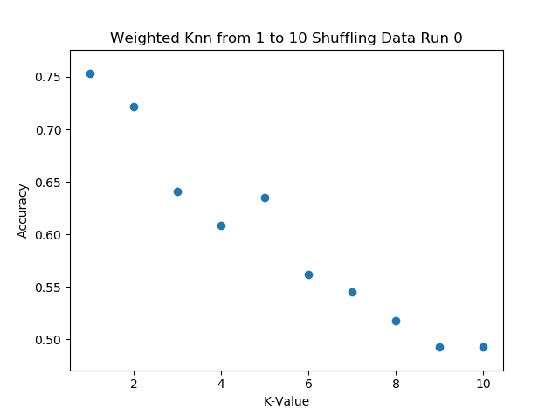 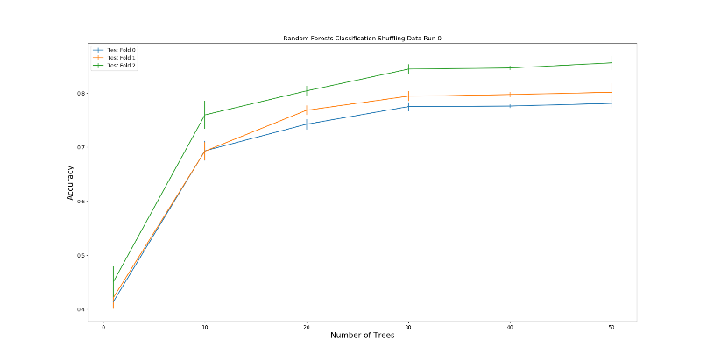

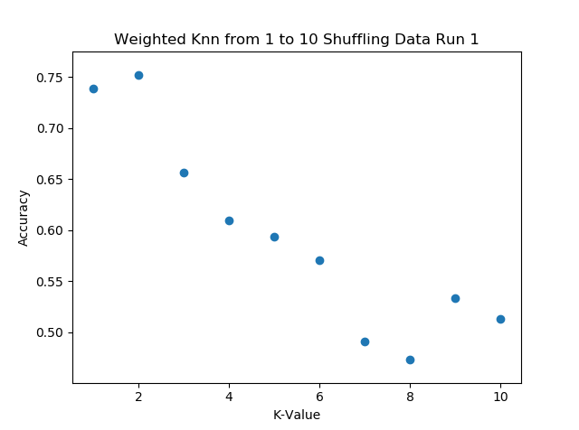 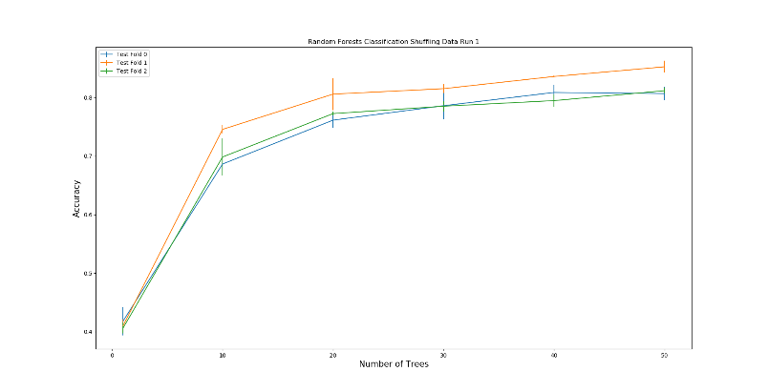

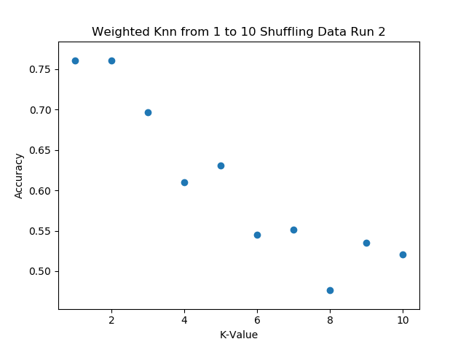 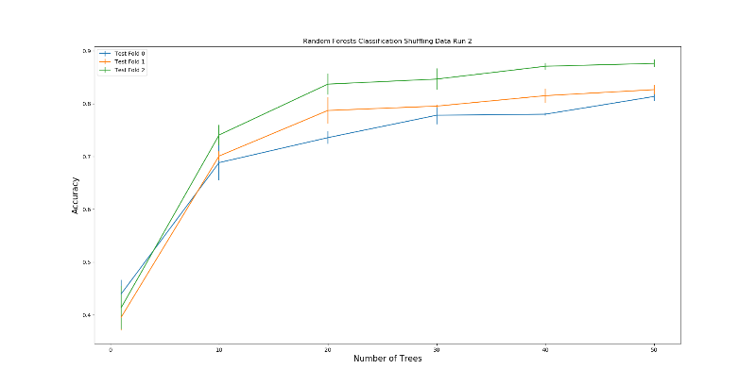

**Figure 5:** The graphs above depict the results when the data was shuffled and ran with a 70/30 percent split. Ran 3 times. The number of trees used ranged from 0 to 50.

We see that with our KNN we get an accuracy of 70-75%, and with Random Forests roughly 80%. For our K-Nearest Neighbors as we increase K our accuracy drastically decreases. The best K value for us was 1 or 2. The optimal number of trees in our random forest was about 30-40.

1. **Are there any issues with your preprocessing or feature extraction? What are they? Why are they issues? What is your plan for future development in project?**

We’ve had several issues preprocessing our images. The first thing we noticed in our dataset vs other datasets is that our images are clear and have little noise. In other images people left in their shoulders, arms, and various other background noise. We decided to create some preprocessing algorithms which try to find the hand and crop around it, this worked effectively for hand symbols which were condensed, but for letters like ‘L’ or ‘G’ part of the finger strays away from the condensed mass so we lost a part of our fingers in preprocessing. It was difficult to find the correct libraries which had things we could use for this project. We haven’t previously done any work with feature extraction or preprocessing, and most of the articles and research papers we found were already advanced enough that they didn’t really need to explain what they were doing.

Another difficulty with preprocessing was finding a data structure that we could use that was compatible with the libraries that we found. We settled with a 3d matrix, but encountered some issues flattening it down for other libraries.

We looked at several feature extraction algorithms, mainly “SURF”, “SIFT”, “ORB”, edge extraction, and others. Surf and Sift became patented so they were removed from the opencv library but were replaced by a new and improved “ORB”. We found several orb implementations, namely on opencv and scikit-learn image. We ran into an issue with the opencv version because there was a lack of documentation regarding how the images should be loaded into Orb. With the opencv version, we found that images had to be grayscale. The opencv version also required images to vary in contrast between pixels. We will continue looking at the opencv version of ORB as well as other feature extraction techniques that we haven’t seen yet.

For the future we plan on exploring more preprocessing and feature extraction algorithms and how we could modify them to work for our specific project. There has already been a lot of research done on hand symbol recognition, but that uses video feed and background subtraction strategies to get the hand. We also will look into using Convolutional Neural Nets once we begin using PyTorch and learn more about them. It seems that CNN’s are the modern way of dealing with problems like this, and since PyTorch has much more support than the libraries we were looking at, there might be some new possibilities for tackling this problem.